This file was created by Ciaran On Wednesday 18th of October at around 10:05am.
The master file was originally saved to the desktop.
The master file originally had the following properties

The master file originally contained an image.
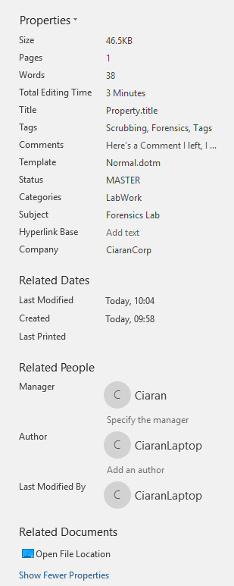
Des has edited the file…

Daniel made a whopper edit to this document!!!!!!!!

